**CS 445 – Week 5 Assignment**

**Matt Hartigan**

**9-June-2019**

**Bullet 1:** Write CREATE TABLE statements to create the tables for the Investco Scout Funds Database depicted by the relational schema created in mini case MC1 in Chapter 3.

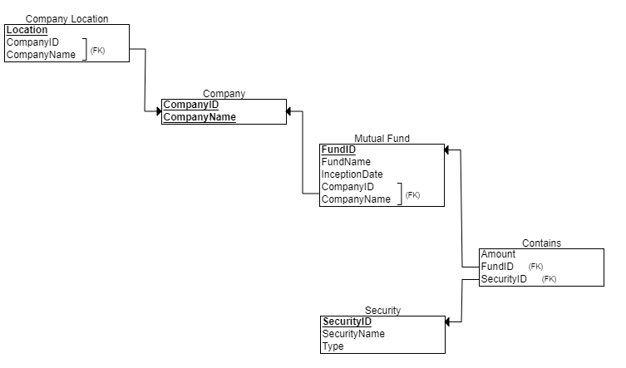

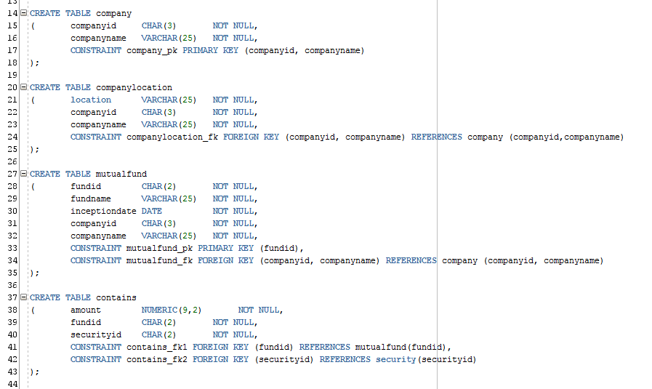

**Bullet 2:** Assume that the following addition is made to the Investco Scout Funds Database requirements listed in mini case MC1 in Chapter 2.

**\*\*\* NO ACTION REQUIRED FOR THIS BULLET \*\*\***

**Bullet 3:** Change the ER diagram created in mini case MC1 in Chapter 2 to reflect the new addition to the requirements.

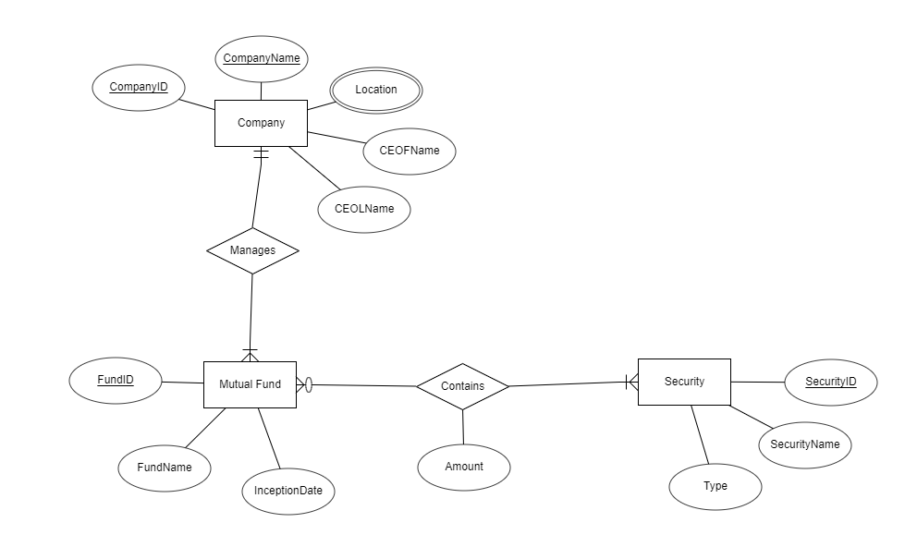

**Bullet 4:** Change the relational schema created in mini case MC1 in Chapter 3 to reflect the change in the ER diagram.

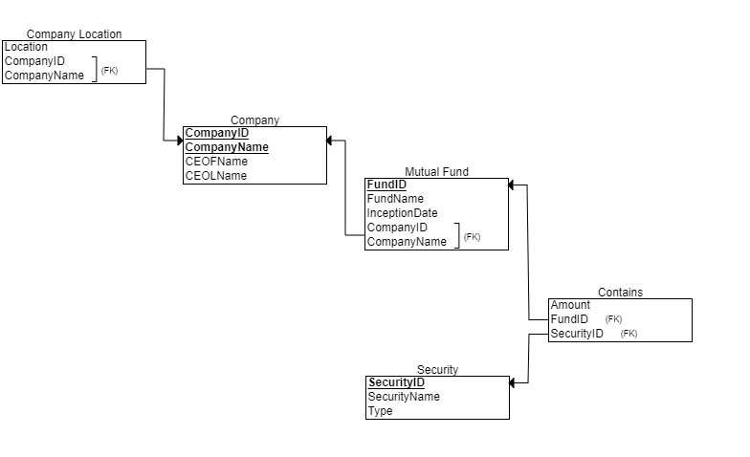

**Bullet 5:** Write ALTER TABLE commands that reflects the change in the relational schema.

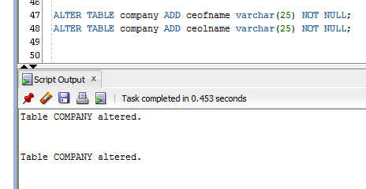

**Bullet 6:** Observe the following information about investment companies and mutual funds and create INSERT INTO statements that insert the information listed below into the created tables of the Investco Scout Funds Database.

